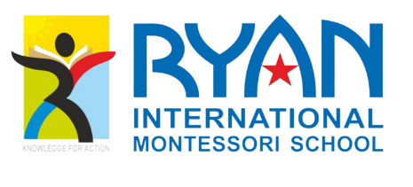

8TH ANNUAL SPORTS MEET OF RYAN INTERNATIONAL MONTESSORI SCHOOL

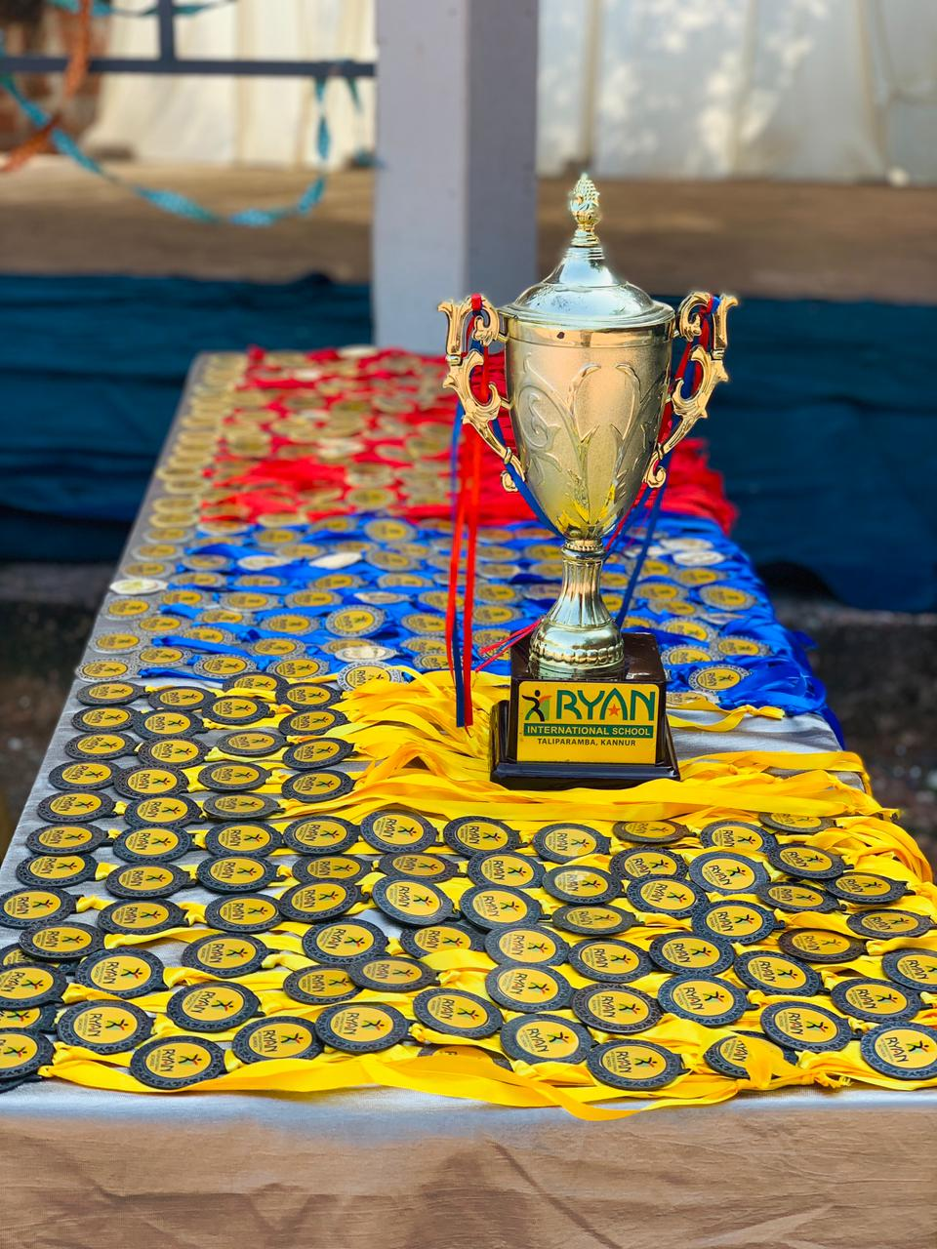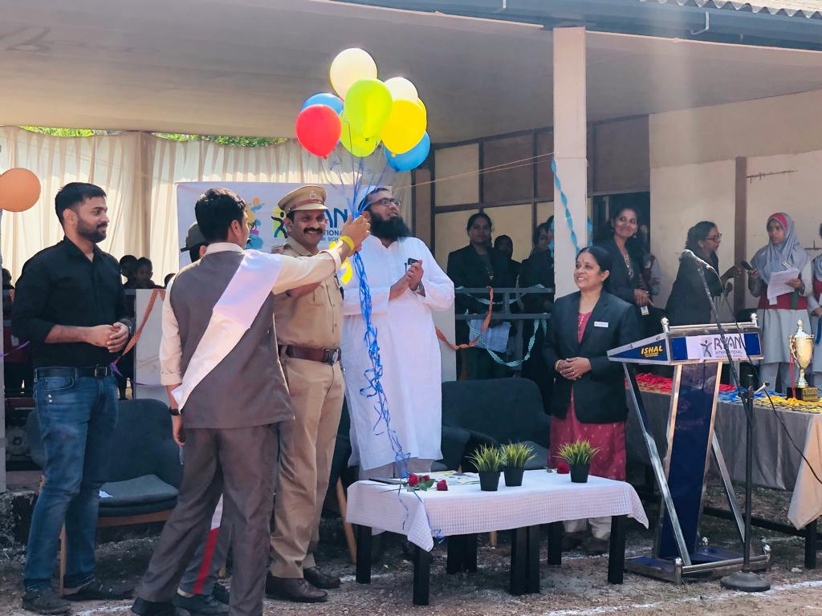

The annual sports day was held on Saturday, 17th January at the school grounds. The event was a grand success, with students from all grades participating in various sports activities. The Inspector of Police, Taliparamba Mr. Dinesh P V was the chief guest of the event.
The day started off with the opening ceremony, which was graced by the chief guest, Mr. Mr. Dinesh P V, The Inspector of Police. After the prayer, the chief guest declared the sports day open, and the events began.

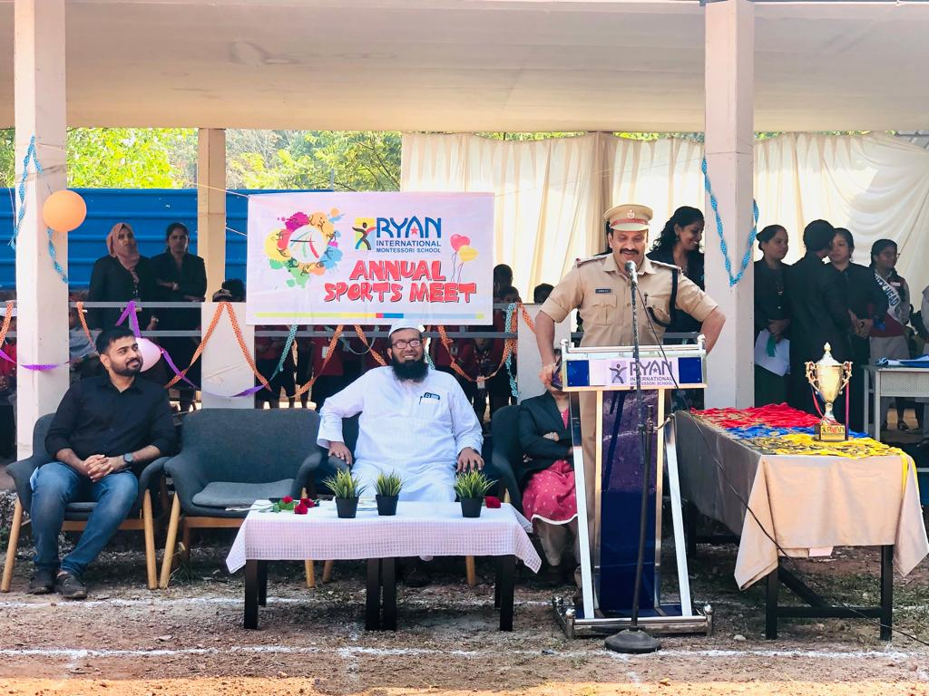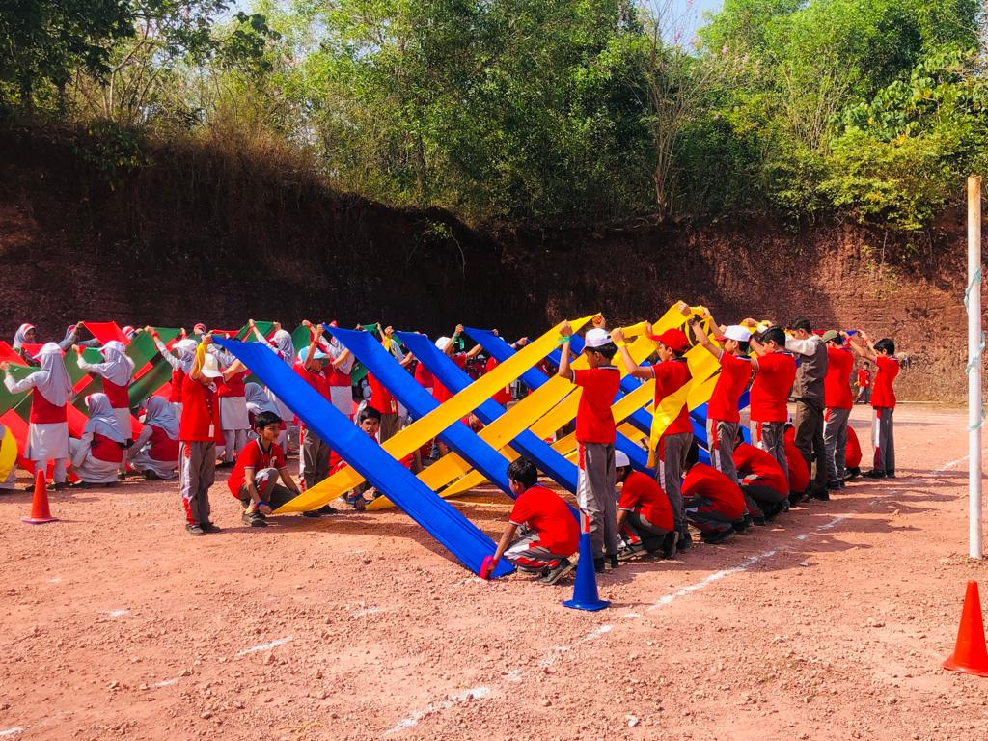

The atmosphere on the ground was electrifying, with students cheering on their peers and teachers encouraging and guiding them throughout the day. The events included running races, relay races, shoot-out and long jump, among others.

The events were divided into different age groups, and the participants showed great enthusiasm and sportsmanship. The most exciting event was the relay race, in which students from each house participated. This was the final event of the day, and the atmosphere was charged with excitement and anticipation.

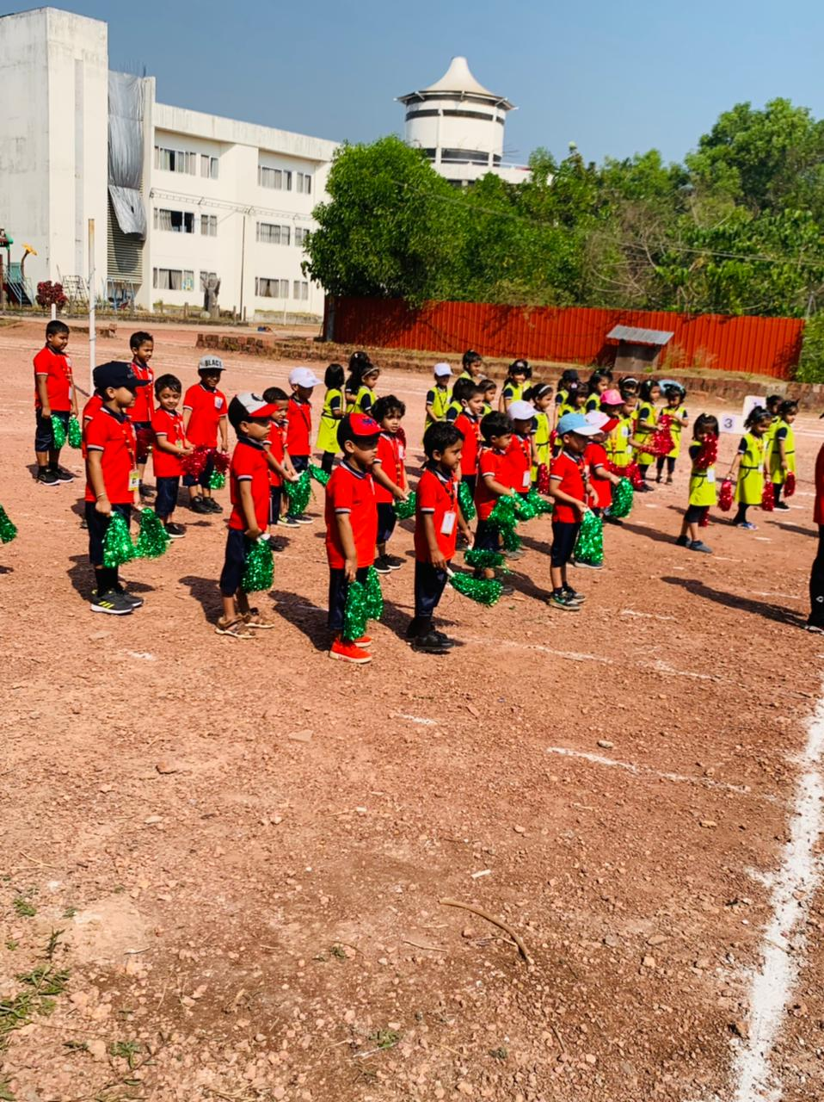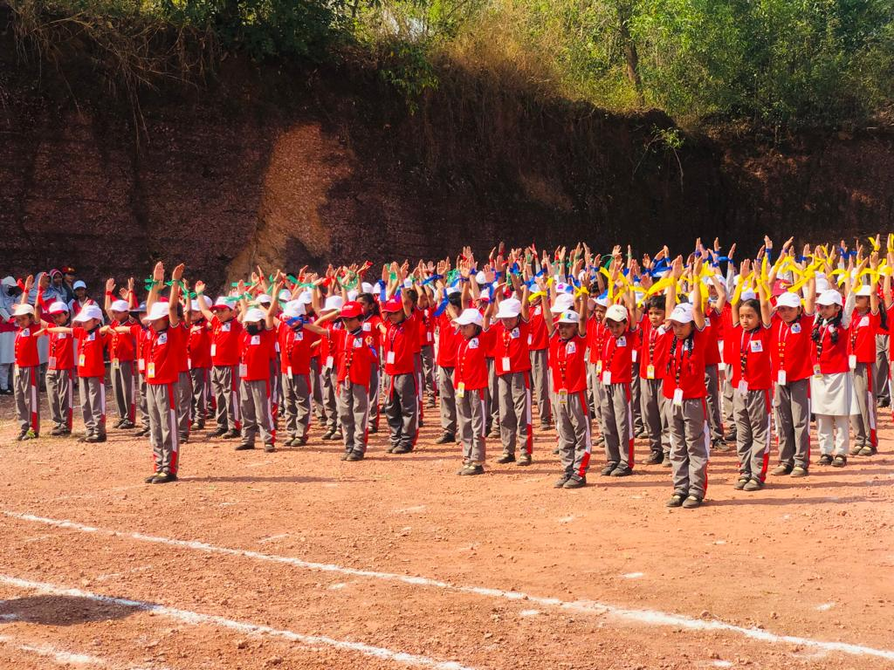

After a full day of competition, the closing ceremony took place. The chief guest congratulated the winners and distributed prizes to the participants.
The student who won the most events and showed the greatest display of sportsmanship was awarded the Best Sportsman trophy.
The principal, Mr. Anis M K , delivered a speech, in which he congratulated the students and encouraged them to continue participating in sports activities. He emphasised the importance of sports in a student's life and how it can help shape their character.

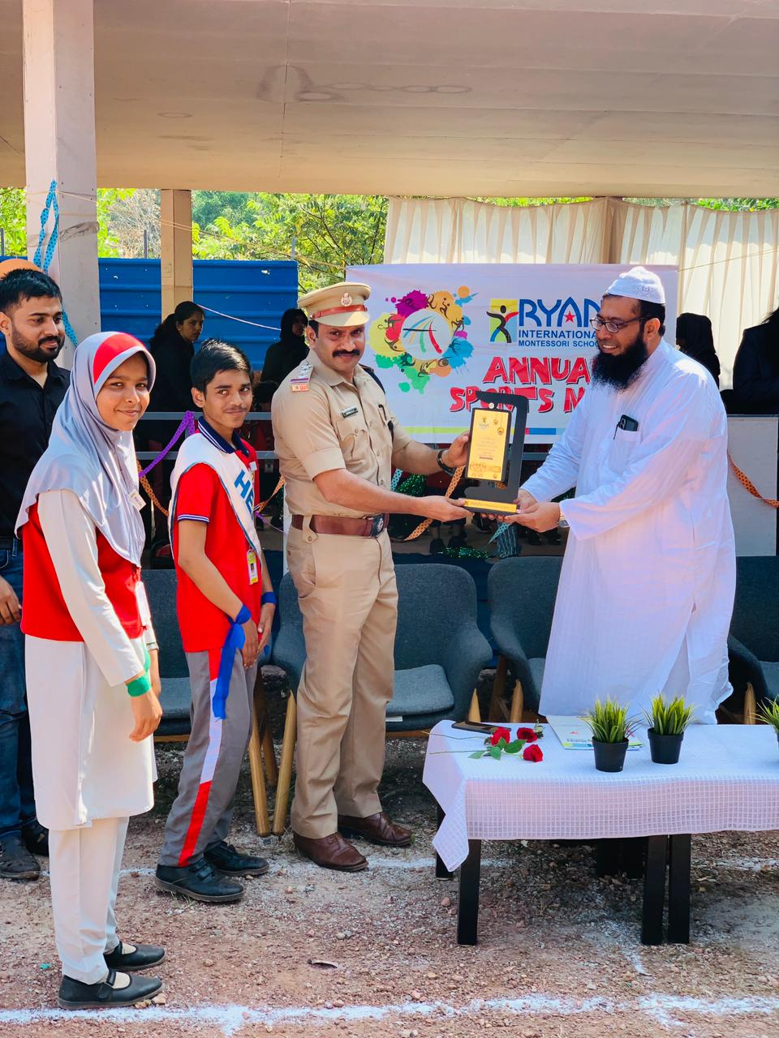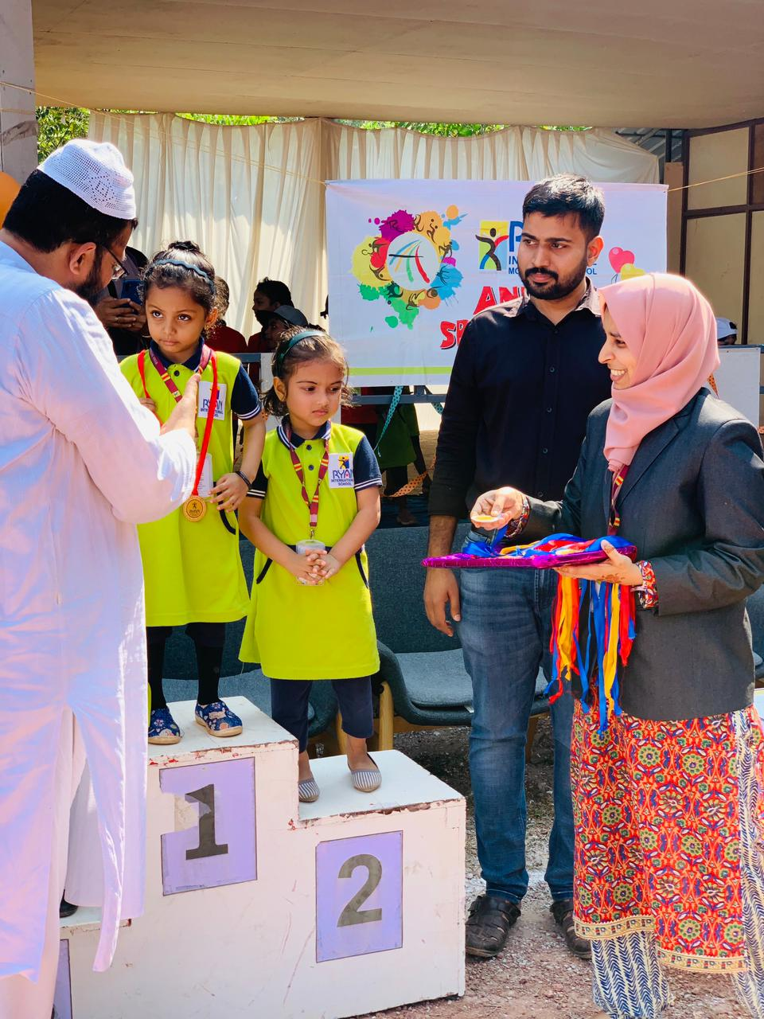

In conclusion, the annual sports day was a grand success, and it provided a platform for students to showcase their talent, sportsmanship and teamwork. The event was an excellent opportunity for students to take a break from their studies and engage in physical activities. The spirit of healthy competition and teamwork was evident throughout the day, and everyone left the event with a feeling of accomplishment and camaraderie.

