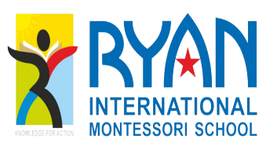 RYAN INTERNATIONAL MONTESSORI SCHOOL

ANNUAL DAY REPORT

The annual day event of our school was held on 11TH March 2023. The day was filled with excitement, entertainment, and lots of celebration. The event was organized to commemorate the achievements of our students and staff, as well as to recognize their contributions to the school.
Opening Ceremony:
The event began with a warm welcome by Ms. Rajeena Mohamood (Montessori Head, Ryan International Montessori School), address by the Principal Mr. Anis M K, inaugural address was given by Dr. Ramis M K ( Principal,P. A Cpllege of Enginering Mangalore) who gave an inspiring speech to the students, teachers, and parents. The keynote address was given by Dr. Shareef Povval (Principal, ICA Thrissur) who highlighted the importance of such events in the school calendar and how they help in promoting the school's values and ethos. The other renowned personalities on the dias includes Mr. Basheer Edat( Councelling Psychologist) , Ms. Anita C ( Chairperson, Health and Education Committee), Mr. Subair M ( CMH Ryan Foundation India), Mr. Muhammed Rinash P (Managing Partner, Sony Electricals).

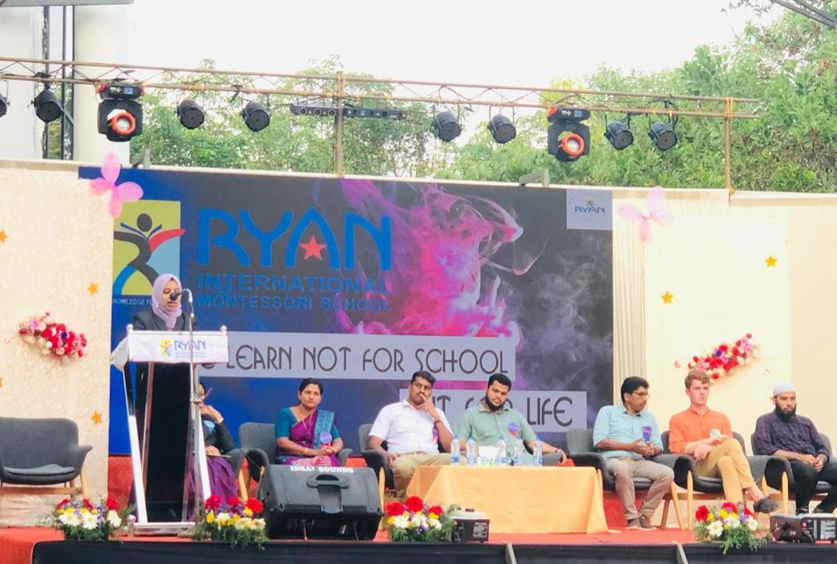

Cultural Programs:
The highlight of the annual day event was the cultural program organized by the students. They performed various dances, songs, skits, and dramas, showcasing the diverse cultures and traditions of India. The performances were a true reflection of the hard work and dedication put in by the students and teachers.
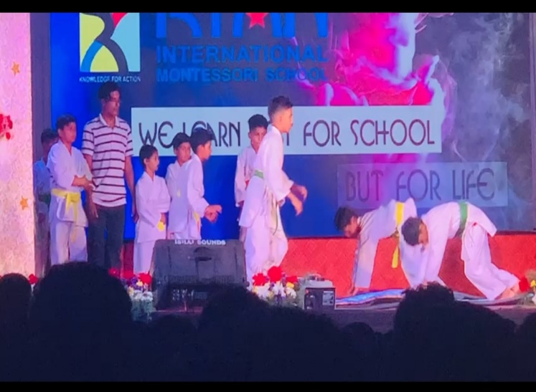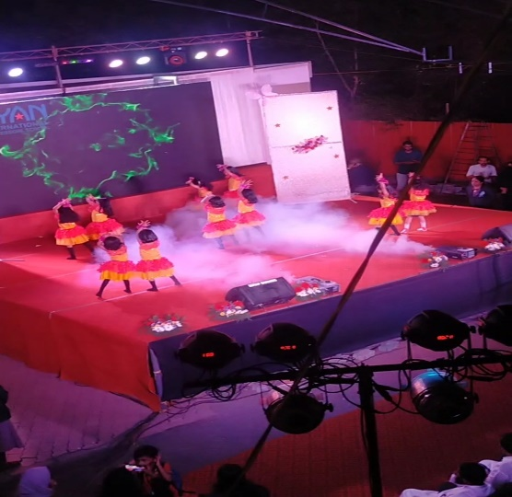

Academic Awards:
The academic achievements of the students were acknowledged with the presentation of awards for academic excellence in different subjects. The toppers of each class were also felicitated, and their efforts were recognized.

Sports Awards:
The students who excelled in sports were also recognized and felicitated for their efforts. The school sports team, which had brought laurels to the school in various inter-school and district-level competitions, was also appreciated.

Felicitation of Teachers:
The annual day event also provided an opportunity to recognize the efforts of our teachers who had worked hard throughout the year to impart knowledge and shape the future of our students.
The teachers who had completed significant years of service were felicitated, and their contributions were acknowledged.

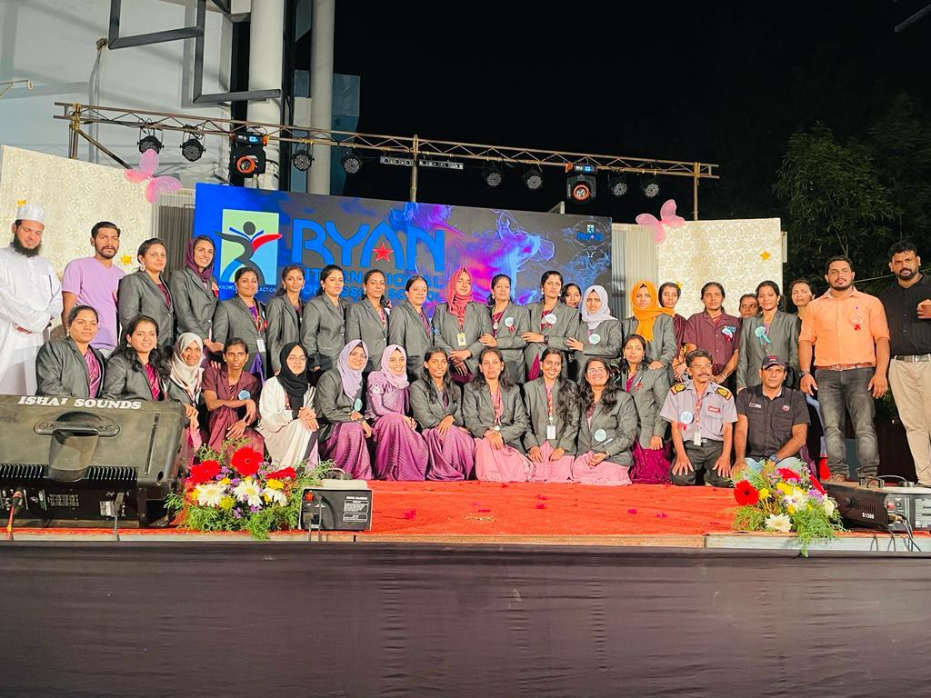

Conclusion:
In conclusion, the annual day event was a grand success, and it would not have been possible without the tireless efforts of the students, teachers, and the school management. The event was a celebration of the school's culture, values, and achievements, and it left a lasting impression on everyone who attended. The annual day event has become an integral part of our school calendar, and we look forward to the next one with much anticipation.
